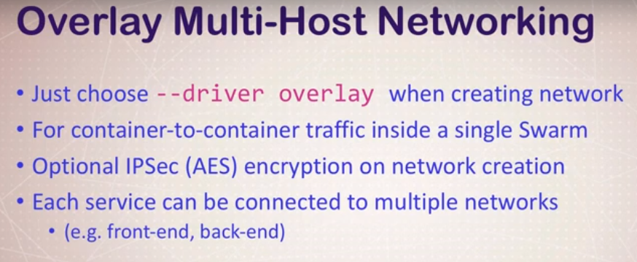

Create network -

docker network create --driver overlay mydrupal

docker network ls

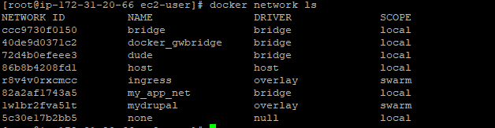

Create postgres –

docker service create --name psql --network mydrupal -e POSTGRES_PASSWORD=mypass postgres

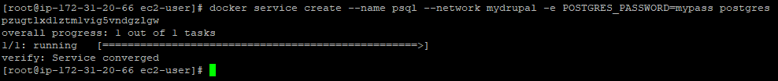

Create drupal –

docker service create --name drupal --network mydrupal -p 80:80 drupal

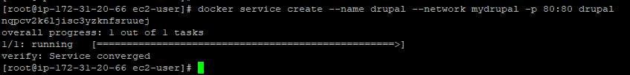

Docker service ls



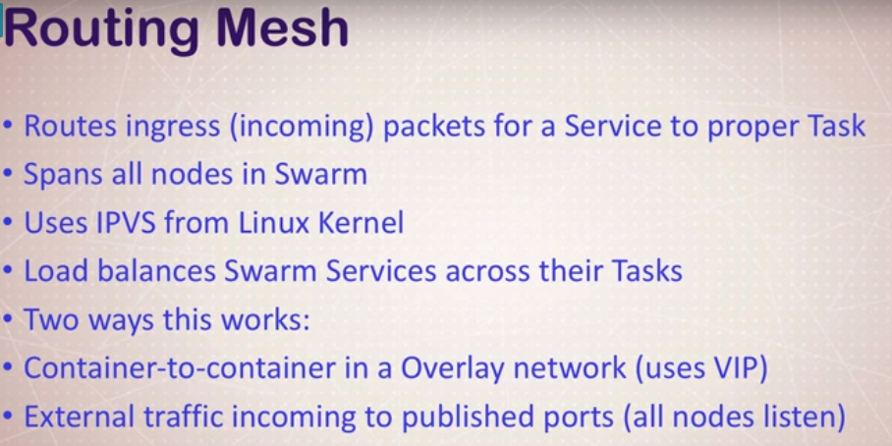

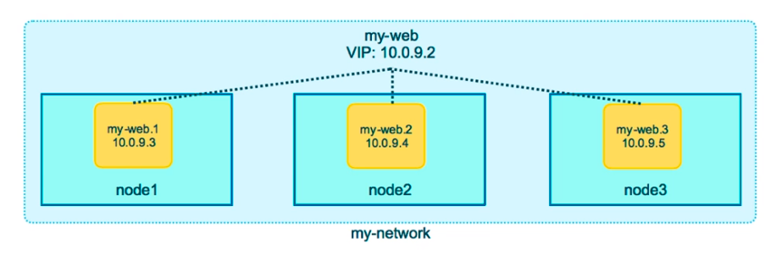

docker service create --name search --replicas 3 -p 9200:9200 elasticsearch:2

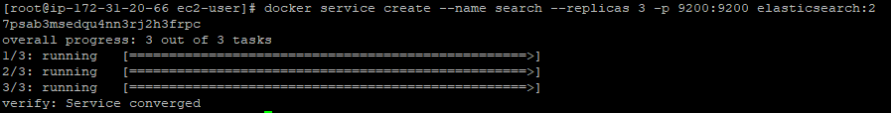

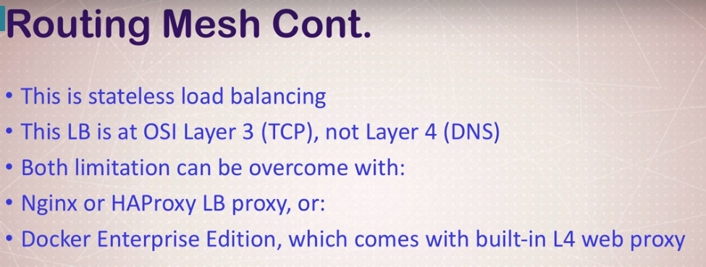

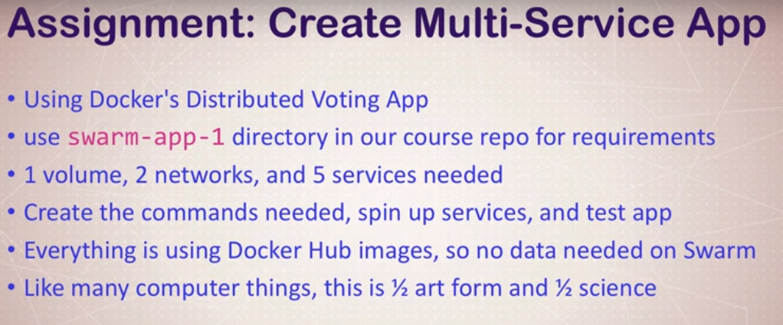

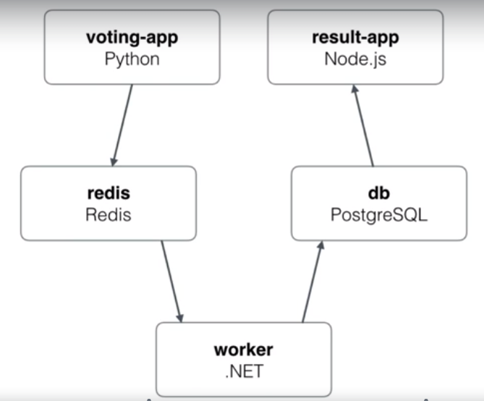

Create backend and frontend network –

docker network create --driver overlay backend

docker network create --driver overlay frontend

Create vote service –

docker service create –name vote –network frontend -p 80:80 --replicas 2 dockersamples/examplevotingapp_vote:before



Create redis service –

docker service create –name redis –network frontend --replicas 2 redis:3.2

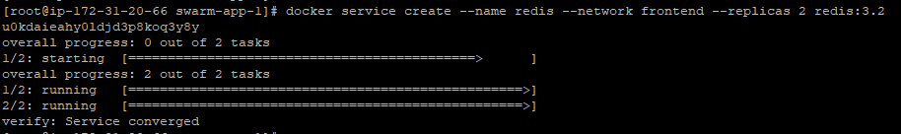

Create worker service –

docker service create –name worker –network frontend –network backend dockersamples/examplevotingapp_worker

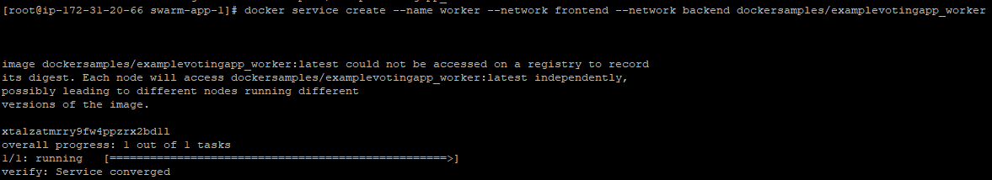

Create db service –

docker service create –name db –network backend --mount type=volume,source=db-data,target=/var/lib/postgresql/data postgres:9.4

Create result service –

docker service create –name result –network backend -p 5001:80 dockersamples/examplevotingapp_result:before



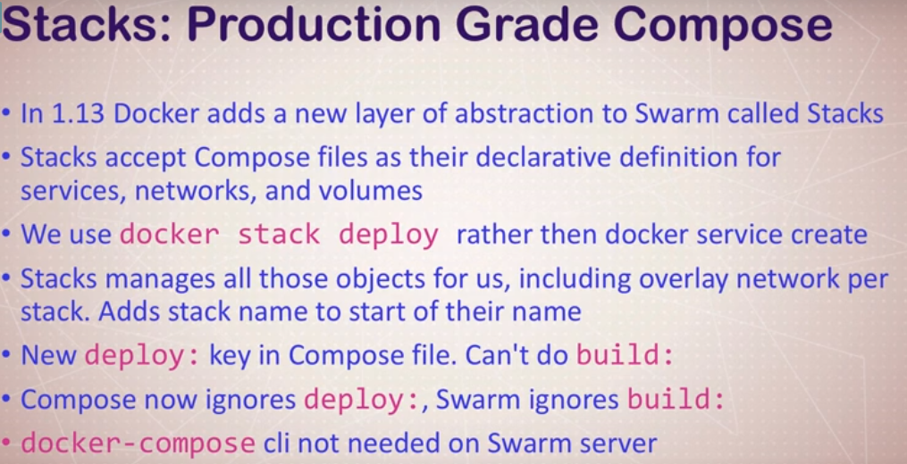

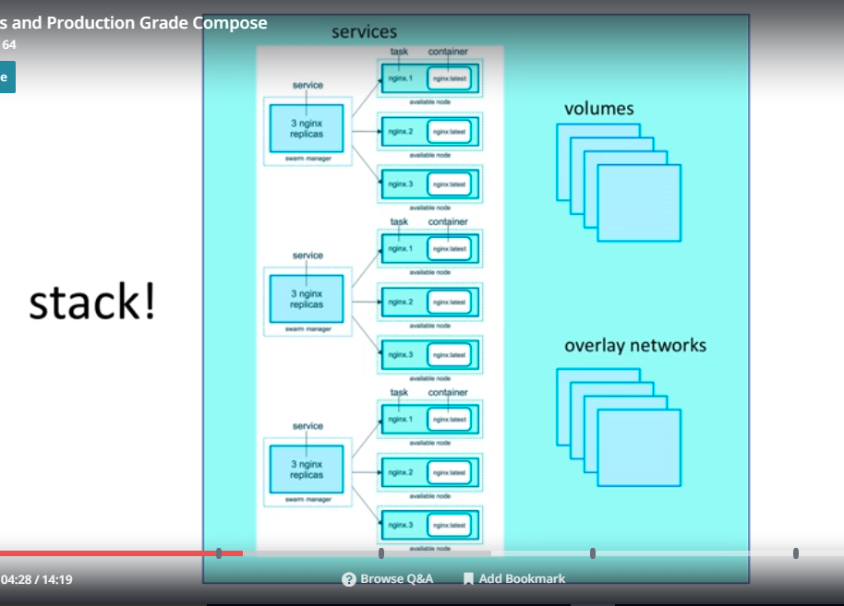

docker stack deploy -c example example-voting-app-stack.yml voteapp

docker stack ls voteapp

docker stack ps voteapp

docker stack rm voteapp

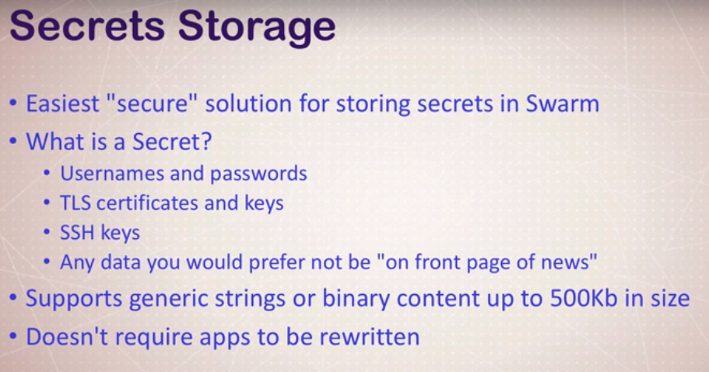

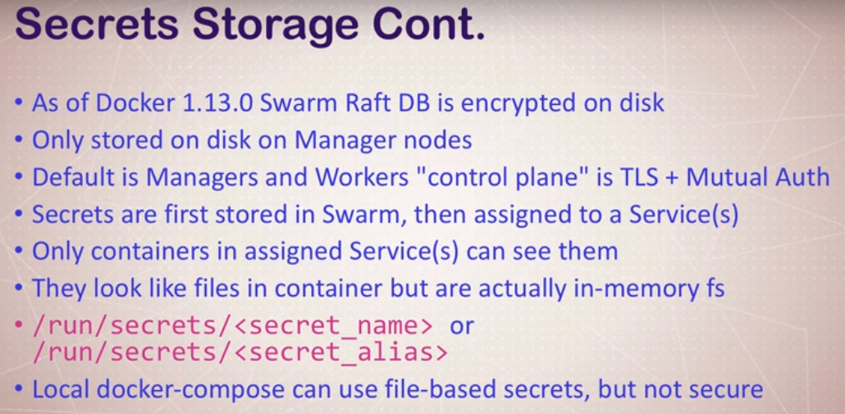

docker secret create psql_user psql_user.txt

echo “myDBpassWORD” | docker secret create psql_pass –

docker secret ls

docker service create –name psql –secret psql_user –secret psql_pass -e POSTGRES_PASSWORD_FILE=/run/secrets/psql_pass -e POSTGRES_USER_FILE=/run/secrets/psql_user postgres

docker service update –secret-rm

docker stack deploy -c docker-compose.yml mydb

